**Polish / Czech films from the Communist Period, 1944-1989**

Nazi Occupied Warsaw 1939-1944; Red army entered Warsaw January 1944

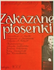

February 2 First Postwar Polish film

**Forbidden Songs** / Zakazane piosenki, 1946, 97 min.

Dir. Leonard Buczkowski

Script, Jan Fethke, Ludwik Starski

Danuta Szaflarska, Jerzy Duszyński

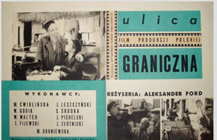

February 9 Polish-Jewish Relations

**Border Street** / Ulica graniczna

1948 Venice Film Festival, 110 min.

Dir. Aleksander Ford

Script, Jan Fethke (Jean Forge), and

Aleksander Ford, Ludwik Starski

Made in Prague: Barrandov Studio

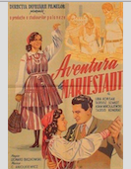

February 16 *‘Socialist Realism”*

**Adventure in Marienstadt** / Przygoda na Mariensztacie

1953 (released January 1954), 93 min.

Dir. Leonard Buczkowski

Script, Ludwik Starski

Lidia Korsakówna, Tadeusz Schmidt

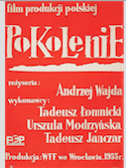

February 23

Forerunner to *The Polish School*, 1956-early 60s

**A Generation** / Pokolenie, 1954, 83 min.

Dir. Andrzej Wajda

Script, Bohdan Czeszko, novel and screenplay

Urszula Modrzyńska, Tadeusz Łomnicki

Alternatively, Wajda’s most famous film

**Ashes and Diamonds** / Popiół i diament

*Polish School,* 1958, 103 min.

Dir. Andrzej Wajda

Script, Jerzy Andrzejewski, novel and screenplay

Zbigniew Cybulski, Ewa Krzyżewska

Locations, Wrocław and Trzebnica, Lower Silesia

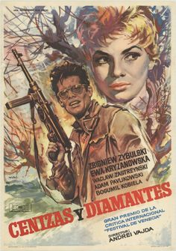

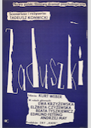

MMarch 1 *“Our Small Stabilization,*” 1960s

**All Souls’ Day** / Zaduszki, 1961, 93 min.

Dir. and script, Tadeusz Konwicki

Ewa Krzyżewska, Edmund Fetting

Location, Warmia-Mazuria

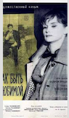

March 1 Alternatively

**How to be Loved** / Jak być kochaną, 1963. 97 min.

Dir. Wojciech Has

Scrip. Kazimierz Brandys

Barbara Krafftówna. Zbigniew Cybulski

Location. Kraków. Warszawa

March 8 Czech film “Banned Forever”

**[A Report on] The Party and the Guests** /

O slavnosti a hostech, 1966, 71 min.

Dir. Jan Nemec and screenplay

Script, Ester Krumbachová, story and screenplay

Location, Filmové Studio Barrandov

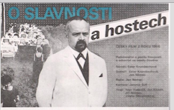

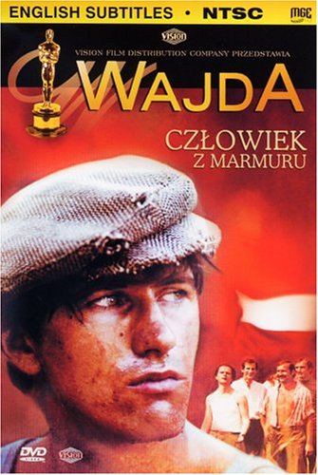

March 22 *Cinema of Moral Concern,* 1976-81

**Man of Marble** / Człowiek z marmuru, 1976, 160 min.

Dir. Andrzej Wajda

Script, Aleksander Ścibor-Rylski

Krystyna Janda, Jerzy Radziwiłowicz

Location, Warsaw, Kraków, Zakopane

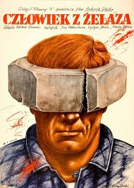

Sequel, **Man of Iron** / Człowiek z zelaza, 1981, 158 min,

Dir, Andrzej Wajda

Script, Aleksander Ścibor-Rylski

Jerzy Radziwiłowicz, Krystyna Janda

Location, Gdansk Shipyard and Central RR Station

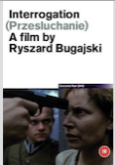

March 29 *Martial Law* from December 1981

**Interrogation** / Przesłuchanie, 1981 but banned until

December 1989, 118 min.

Dir. Ryszard Bugajski

Script, Ryszard Bugajski and Janusz Dymek

Krystyna Janda, Agnieszka Holland